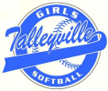

Dear Past and Potential Sponsors,
The Talleyville Girls Softball League (TGSL) is now preparing for its 55th season in the Brandywine Hundred area. TGSL provides recreation, competition and above all, fun for girls four to nineteen years of age. TGSL is one of the largest and fastest growing softball organizations in Delaware. At present, the league is comprised of over 45 recreational teams and 5 travel teams with the participation of over five hundred and fifty girls. Because TGSL is a non-profit organization, your contribution through sponsorship is tax deductible. Contributions provide the resources to purchase equipment to maintain our complex at Old Mill Lane, while assuring quality training and instruction for girls in our area. Here are your options!
DIAMOND SPONSOR………………………………………………………….…$550.00 (New Sponsor) Diamond renewal will be $475.00 if you keep the same banner.
- Company name on a team jersey for the entire season.
- Banner with company name displayed at the complex for the entire season (March-Nov).
- Receipt of a team photo plaque.
- Sponsor name in the league book along with a 1/2-page ad (given to every player in league).
- Direct Link from TGSL website to your Company website.
- Invitation to Opening Day, All-stars, and Championship events. You may set up a table or display!
TEAM SPONSOR………………..……………………………………………………………...…...$325.00
- Company name on a team jersey for the entire season.
- Receipt of a team photo plaque.
- Sponsor name in the league book (given to every player in the league).
- Direct Link from TGSL website to your Company website.
- Invitation to Opening Day, All-stars, and Championship events. You may set up a table or display!

BANNER SPONSOR……………...……………………………………………….. $250.00 (New Banner) Yearly banner renewal of $150.00
- Banner with company name displayed at the complex for the entire season (March-Nov)
- Sponsor name in the league book (given to every player in the league).
- Open invitation to all events. You may set up a table and/or display!
AD SPONSOR (Business Ads)
- Company advertisement displayed in a forthcoming TGSL yearbook.
  - Full page $100, Half page $75 and Quarter page $50
*All sponsors may set-up a table and/or a display and attend Opening day, Championships and All-star night. This is a great opportunity to promote your business and see Talleyville Girls Softball in action!

2024 Payment Options
This year we will be offering two options for payment. You may either mail a check or pay with Venmo. Please mail all checks to: Laura Miracle - 9 Tenby Drive, Wilmington DE 19803.

OR
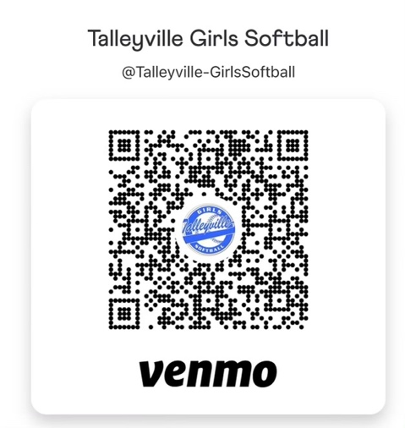
If you have sponsored in the past, a google form will be emailed to you in the next week or so. If you are new to sponsoring, please email TGSLSponsors@gmail.com and the google form link will be sent! All forms and payment due by 2/15/24!
- If you are a new sponsor, or your logo has changed from the previous year, please email an electronic advertisement or logo to TGSLSponsors@gmail.com.
- In an effort to keep things running smoothly as we prepare for the upcoming season, payment and artwork are due as soon as possible!!
Final deadline is February 15th, 2024.
On behalf of the girls and the many volunteers, we sincerely thank you for your support and for becoming part of our organization. We are proud of the positive and exciting opportunities we are able to provide for a growing number of young girls year after year.
Sincerely,

Laura Miracle
TGSL Board Member Sponsors

TALLEYVILLE GIRLS’ SOFTBALL TAX ID#: 20-1798170

